System – Fax Forwarding
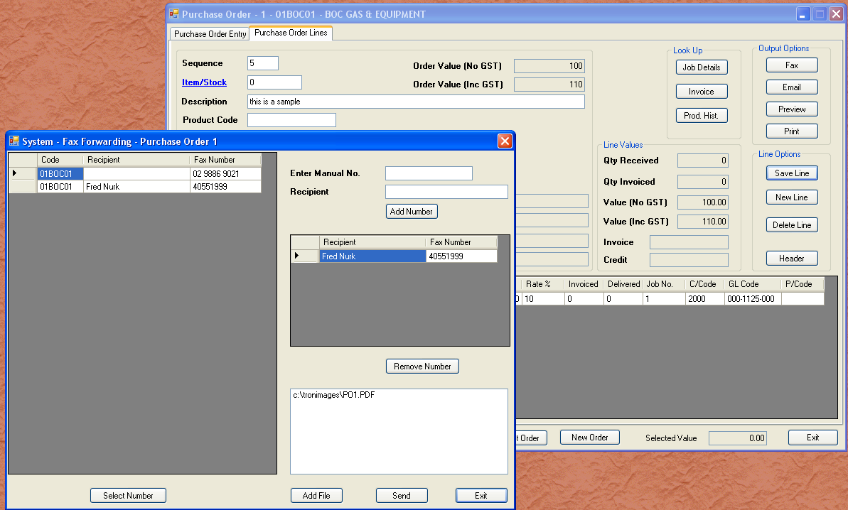
Similar to email forwarding, the module that asks for fax forwarding is responsible for pre-filling address and fax numbers. In the example above, we have elected to fax instead of email. The fax numbers are those stored in the creditor master. The purchase order is converted to a PDF document, and you are able to add more PDF documents. No other format is allowed. The fax does not send a header at this stage, but I will add a header feature that can be turned on. This would be valuable for orders that include documents that require some pre advice.
If the fax is not able to be delivered to the destination, you will be advised by email.

