Purchase Order - Query
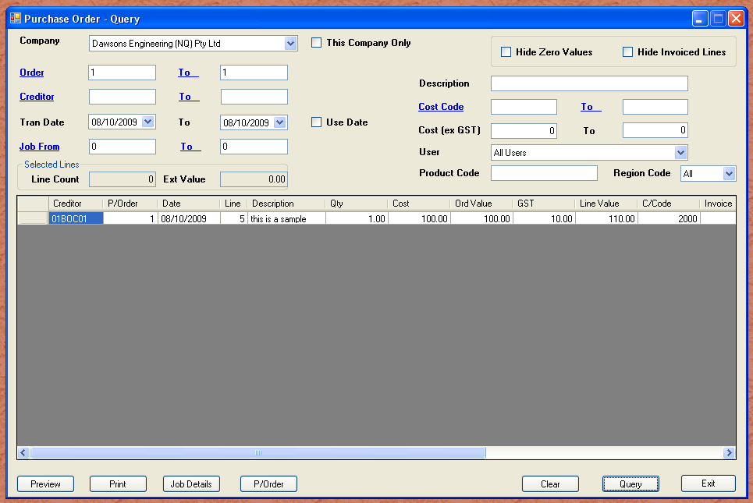
One of the frustrating things in life is having thousands of useful records, and limited ways of searching it. The above module allows you to be very vague, and find the most obscure things. In the above example I have simply searched for order number 1. (Not a very impressive example.) I don’t have any data yet, but you will be able to say search all purchase order across all companies in the group, for the simplest things.

Suppose we wanted to find all the dumpy levels we either bought or hired. Simply type “dumpy” in the description field and click query. In about one second you will have the grid filled with all the purchase order lines with the word “dumpy” anywhere in the sentence. You might get say 20 results. You could be happy with that, or leave the word dumpy in the description field, and put the creditor code “01PAR01” in the from and to creditor fields. Clicking again would narrow the search to only those purchase order lines where the supplier is Paramount hire, and the description has the word “dumpy” somewhere in it.

As you can see, this is enormously powerful. Be vague to begin with, and then narrow down. Once you have the data you want, you can then print or copy or jump to another module, example purchase order, and see the entire order.

