Purchase Order Master
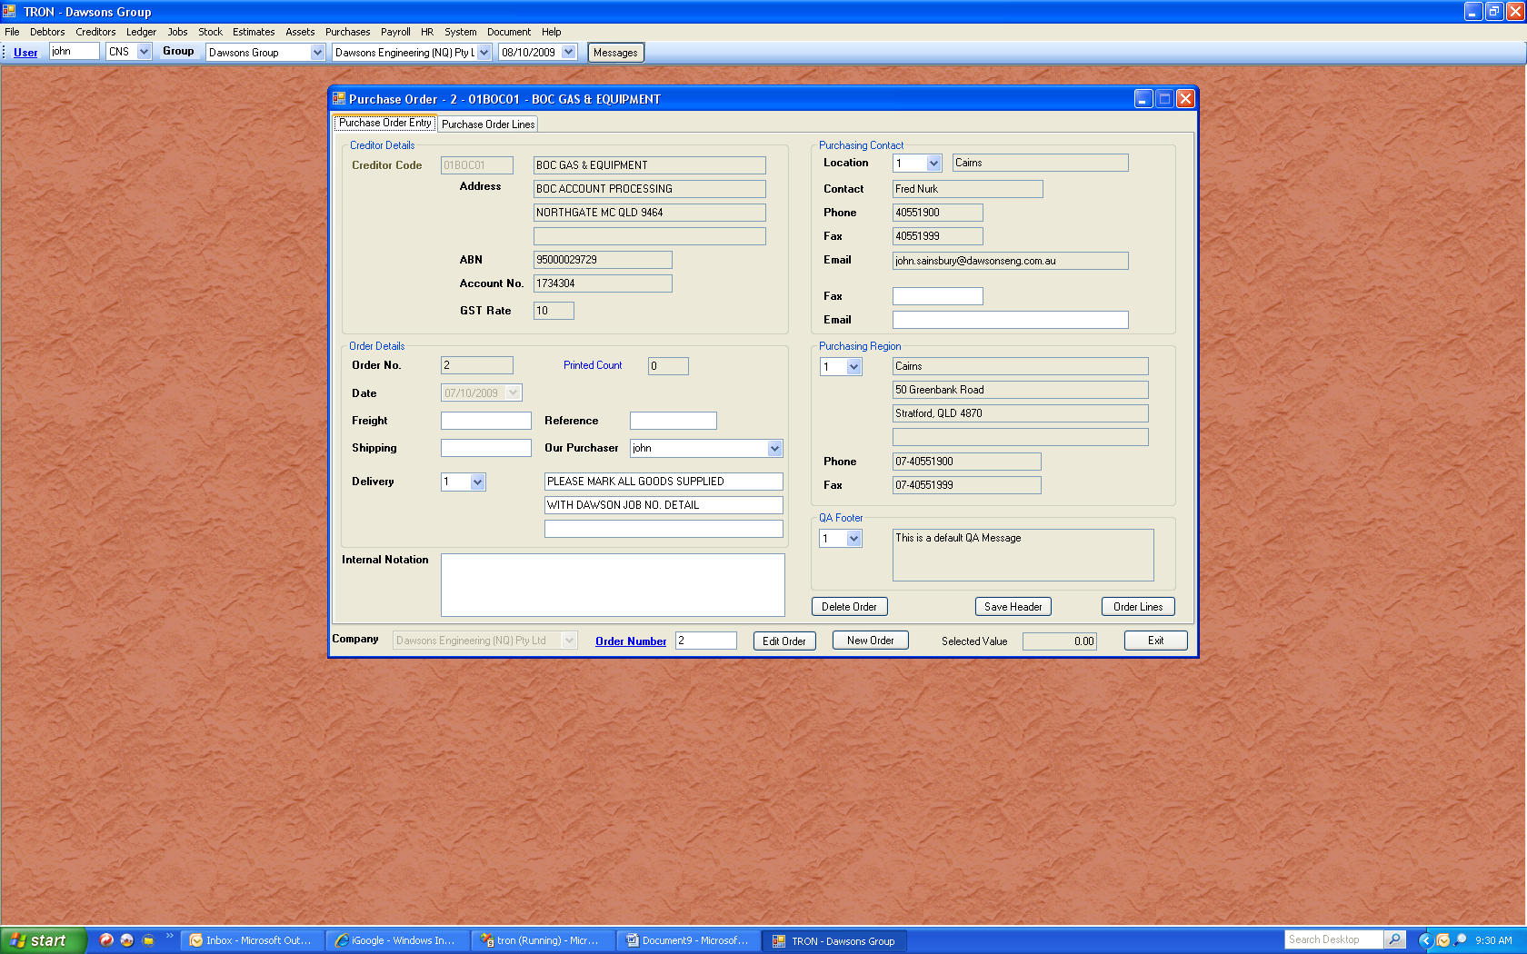
The purchase order master is where we create / edit purchase orders. You can enter a valid order number in the field at the base of the form, and press enter. If a valid order is found, the fields will be filled in as above.

In the creditor master, we can create purchasing contacts, as well as regions. The contact is the person whom we want to send the order to. The creditor master will have a default for both. For exampkle if we are in Townsville, and want to send an order to BOC. The default would probably be set to Cairns. By selecting an alternative, we could direct the order to Townsville. Similarly, the region is the purchasing office location. If we change that to Townsville, then BOC Townsville know the goods are required for Dawsons Townsville.

The field internal note could be a freehand note as to why we used this supplier, even though they were not the cheapest etc. The QA footer is currently not used, but will be implemented on purchase orders.

When you click to add a new order, all fields are cleared or set to defaults. All you need to do is select the creditor code, and the defaults from that creditor are applied. You can delete an order as long as no items have been invoiced. You can change the creditor as long as no items have been invoiced. It is good policy to click the “save header” button before preceeding, however if you click “Order Lines” to proceed to the next tab, or click the “Purchase Order Lines” tab, the header is saved. A header is the one record that stores the information for the entire order. The order lines can be hundreds, that refer to the one master record.

As discussed previously in the overview, the creditor code will determine which company is used. You can use say “01BOC01” (Engineering) to place an order for goods for jobs that are for CTBB; Maintenance Contractors and Dawson Construction all at the same time. One invoice can span all companies in the group. Of course this is unlikely, but possible none the less. The idea is we use Dawsons Engineering for purchasing the goods, that way keeping invoices and statements to one company.

The next tab is the “Purchase Order Lines”. This is where we enter individual lines of the order. Orders can be edited, lines can be added / deleted; job numbers changed; cost codes changed as long as the line has not been invoiced.

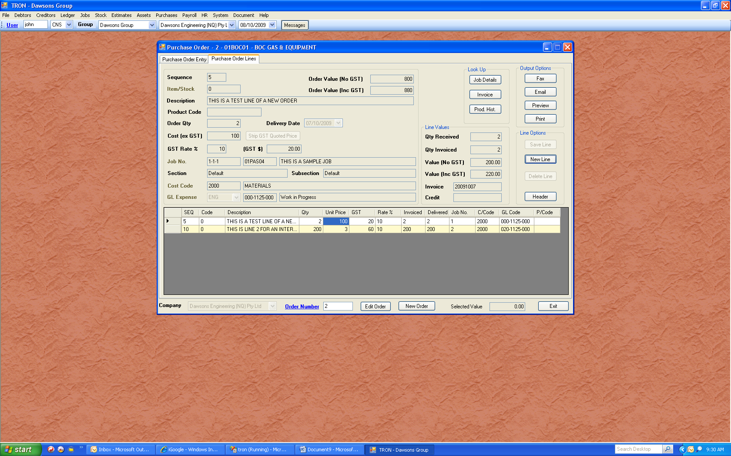
When an order is complete, you can send it directly. You have the choice of printing; email or fax. The fax and email options take you to a pop up that fills with default numbers from the creditor master. You are free to add more recipients, as well as other documents. If you wanted to add a drawing to the order, you would simply select Fax or email, and then chose to add other documents. Faxing is restricted to PDF documents, but email is any document.

The faxes are sent out via a third party service. We send via email to a service provider, and they send on our behalf. The advantages are that the fax is sent immediately, it is cheaper and if the fax does not go, then you are emailed directly to advise your fax would not go. The email carries a brief description of what the problem was. We have trialled this service for over a month, and send out bulk remittances to creditors, approx. 50 at a time. The service works very well.

As most of the invoices for creditors are scanned, you have the ability to view the details if an invoice exists for the current line. The “AP – Status Detail” below shows details of the invoice posted against this line. You can go one further and show the actual invoice from here. You will see the detail shows the purchase order 2, which is the same as the purchase order we are in. The job number and cost code are not listed on the scanned invoice, as these come from the purchase order, where multiple combinations are possible.
