Purchase Order – Invoice Recieval
This module could sit in either purchase orders, or account s payable. The origin of the data is purchase orders, so this is why it sits here. The object of this module is match accounts payable invoices against lines on the purchase order. If the invoice is for a lesser amount than the value of the order, then lines are either not selected, or quantities are back ordered, as the case may be.

Below is the batch screen for a blank batch. We must enter a new or existing batch number, along with a valid posting date.

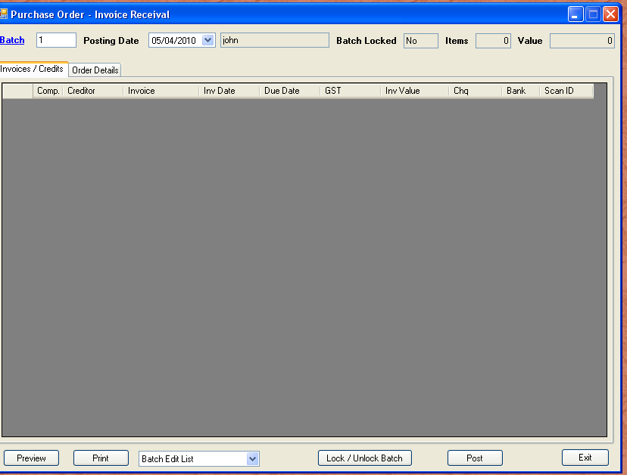

The grid on the first tab shown above is a dynamic list of invoices included in the batch. If we wanted to edit an invoice in the batch, we could either enter in the invoice number field on the next tab, or we could double click a valid line from above, which will pre-fill all fields. If the batch has contents, the counters at the top will adjust accordingly.

Invoices in batches are not yet posted to the general ledger. The value of the outstanding items is included in jobs sub ledger. Below is a sample of an invoice partially received. We nominate the sequence number of the purchase order lines. This is simply the line number allocated during purchase order creation. Lines are incremented by five so as to give room to insert details at a later date if required.

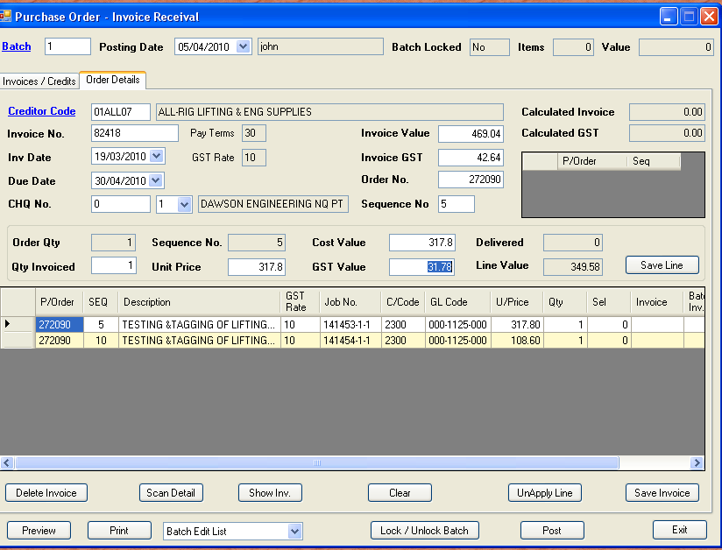

As you can see above, the line selection process imports all values from the original purchase order. Occasionally, the GST values are required to be altered by cents, as suppliers have differing standards for rounding. Tron uses the standard nearest to method.

As soon as we save the current line, the purchase order and sequence is updated in the pick list. The method is that one invoice can span several purchase orders, and this list tracks the selections so far. We are not able to alter the original costing information from the purchase order. If the costing seemed to be incorrect, we would have to exit out and alter the purchase order.

Not quite visible in the purchase order lines grid, is the “Batch Invoice” marker. This indicates this line has already been invoiced in the batch, and if in another batch, what batch number. You may only pick purchase order lines that are in the current batch, or have not been selected elsewhere.

The purpose of this feature is so you can see the entire order, and know which lines have / have not been selected. You will also notice the Sequence number in the invoice details has advanced to “10”. This assumes you would want to, by default, select the next available line. Once all lines have been selected, and the calculated values agree with the invoice values, the cursor highlights the “Save Invoice” button. As soon as you click save, the invoice details are cleared. By default, the previous creditor code is left in use. You can override this code, but generally it is good practice to enter in like groups.
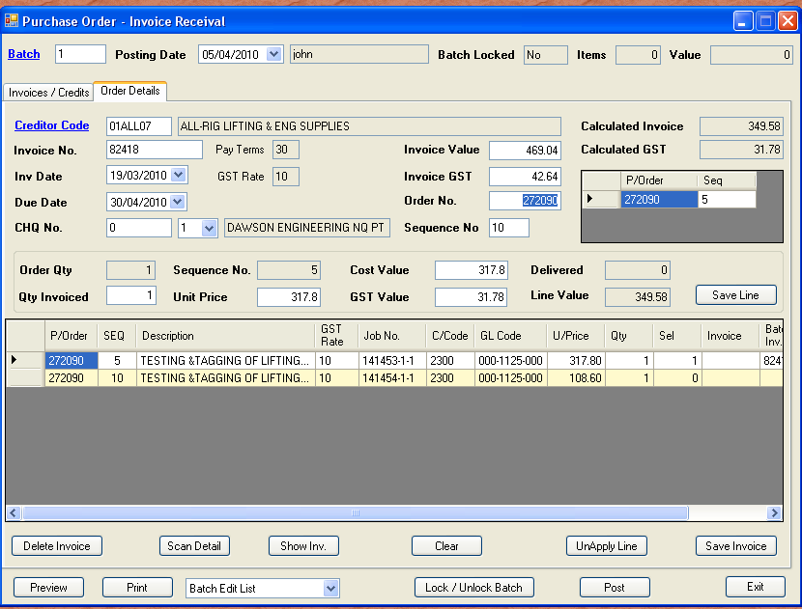

The grid on the first tab fills with the saved invoice details, and the batch values are updated. When all invoices are matched, a “Batch Edit List” is to be printed. There is also the “Approvals” report available. This report gives commentary on invoices approved, and details of who approved the invoices. This report is intended for information only, but could be included with the edit list for audit purposes.

Similar to accounts payable invoice entry, the batch edit list gives a consolidated listing of all general ledger codes affected by the posting of the batch. The format is Account, value, company code. The company code determines intercompany transactions.

