Payroll – Timesheet Entry
All earnings are entered via timesheet entry. This ensures costs are allocated to jobs, and not directly to general ledger. At the end of each payroll, the pay file cannot update to general ledger without all batches being posted. This then ensures all costs are posted to jobs, and work in progress is increased by the increased liability of wages due. The following example shows a typical batch that has been entered, and the current pay period.

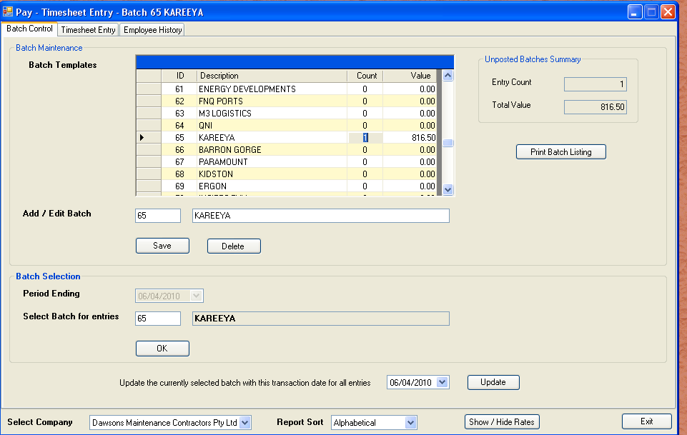

The next screen shows a fictitious payroll entry. From this screen we can learn the following:-

- This is a casual employee
- This is not an intercompany job

You will notice beside the job number is the reference “026”. This tells us the job was created to expense division “026”. The value further to the right “20STA02” is the debtor master code. All jobs must be assigned a debtor code. The prefix “20” of the debtor code tells us this is company 2. The cost code 1000 is standard across all companies. The pay code determines earnings type.

On the right hand side of the screen, are default rates for this debtor code. As we traverse through the job number, the job indicates the debtor, and fills the lower right hand grid with labour rates defined for this debtor. The first rate available in the grid comes from the employee master file. This then gives a visual reference on usual and available rates available. The operator has the power to select the rates or override.

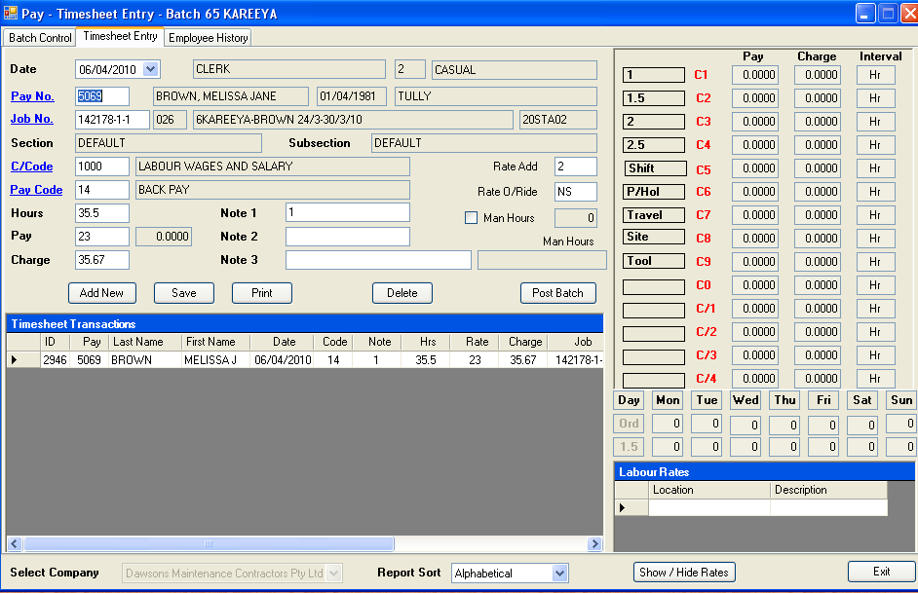

The third tab gives access to previous earnings. This is useful when comparing rates paid over previous periods.

The report is first previewed to screen, and is then available to print. Batches remain un-posted, until all checks are complete.

The “Show / Hide Rates” button shows or hides the rates grid. If hidden, the “Timesheets Transactions” grid is expanded to show more detail. This is handy when entering large amounts of consistent data.

To aid in faster processing of times, there are a couple of shortcuts.

- Entering “+” in the pay rate field will add the nominated rate add value. In the sample above this was 2, representing $2 per unit greater than the base rate.
- Entering “+” in the note 3 field will duplicate the last entry. This field is used for external references, most commonly SAP numbers.
- Entering a “+” in the pay code field will change the pay code to 30. This is the most common pay code
- Entering a “-“in the pay code fields will change the pay code to 32. This is the night shift version of code 30.
- Any field adjacent to a hyperlink can be invoked with an “Alt + S”. The same can be achieved with “F9”
- If there is a large batch under way, and you have an interruption, you can use this spare time to pre-process pays. Simply press “F12”, and wages tax will be calculated etc. When you exit the time required to process is reduced dramatically.
- The “Man Hours” check box adds all man hours for the current pay number, within the batch. This is useful if you need to keep track of complex entries. An employee’s times might be spread across several SAP numbers, and this will aid in tallying the hours as you enter them.
- The red values in the pay rates box to the right of the screen refer to the shortcuts that can be applied to copy the rate. If you want the Shift rate for the currently selected rate group, press “Control + 5” to copy the rate.

