Payroll - Payslip Entry
Payslip entry is used for transactions not affecting gross earnings. The only exception is salary sacrifice, which is an offset to gross earnings. This module is used AFTER all timesheet entries have been completed. Whilst this is not mandatory, it makes good operational sense. Generally, this module is where we enter changed tax values; loan repayments; HECS; Child Support etc.

The process is very simple. You enter a pay number to edit. If the employee has not been loaded, then you will be prompted to agree to enter that employee.

You are not allowed to enter any pay code where the values are to be entered into timesheets. Below is a screen shot of the module.

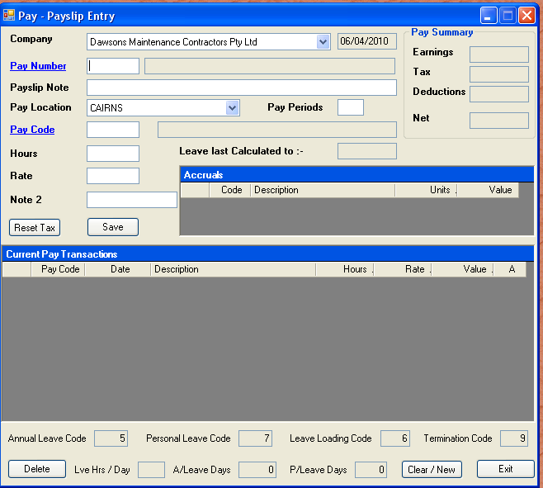

As usual, hyperlinked values can be invoked by pressing “Alt + S”.

