Payroll – Master file Maintenance
The payroll master file contains the details of all employees. Each employee has a unique “pay number” per company, with a consistent GUID number. The GUID number is the employee’s Global Unique Identification Number.

In order to be able to enter a new employee, they must first exist in the Hr Master. This ensures an employee has his HR details available across all companies he may be employed by.

To add a new employee, we need to “look up” a master file record.

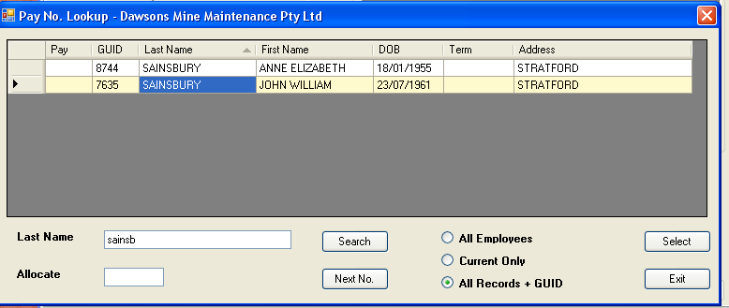

The above “lookup” dialog is accessed by clicking the blue hyperlink “Pay Number”, or by pressing “Alt + S” at the same time. This is a keyboard shortcut. As you can see from the sample above, John Sainsbury does not have a pay number for Dawson Mine Maintenance.

If we wanted to add this person to the current payroll, we would click “Next No.”, to obtain the next highest pay number not currently used. To confirm the selection, click “Select”. At this point the pay number is rechecked to ensure it is correct to use.

If we clicked “select”, and the new number was valid, then we would have a pay master record filled with a number of the details already provided. The fields already provided come from the HR module. The assumption is common data will need to be changed in each company, as it is updated. An analogy is where the employee changes their address. It can be changed in the HR module, or in any of the companies they are registered in. Information is automatically updated across all areas.

Banking and superannuation are static, so if banking is changed in one company, it is changed in all companies. Similarly, if an employee changes their super company by choice, then that change is in all active payrolls. This is true for new payrolls this employee may be engaged on. Below is an example of a default set of data for the selected employee.

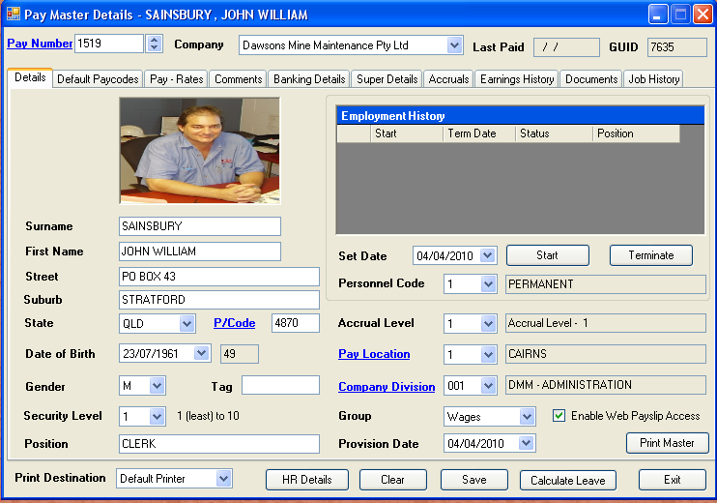

As you can see above, as much information already known is pre-populated. Our first task is to create an employment history record. Simply set the start date (defaults to today) and click start. Ensure you have the personnel code set correctly first. If you make a mistake, you can click the employment grid to show an edit feature.

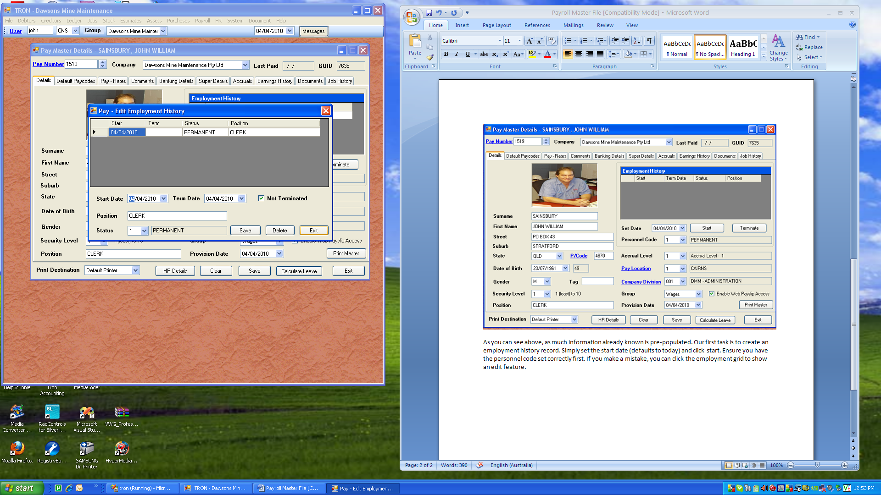

Simply correct the entry and click the save button. The accrual level is 1 by default, and is used for advanced accruals. Generally this is not used. The pay location is a regional setting, used for payslip distribution. By default all new employees are security level 1. Staff employees are set to level 7 so as not to be accessed by other staff by mistake. Details are visible if you have access to the master file maintenance, or master file query, but the details are limited to not sensitive data.

The company division is the usual location of the employee. It is used for statistical reporting etc. As timesheets are entered, the costs are apportioned to the division assigned in the job master.

In order to maximise payroll throughput, there are default settings passed through to each pay process. The most standard default code is the salary sacrifice for super.

The pay rates tab is just that. It is used to define pay rates for the individual if the same rates will be used constantly. This would be true for salary and other permanent employees. We have the option of determining where to print the payslip, and nominating normal working days.

The next tab is comments. Comments are global across all companies, and the company code gives insight into which company the comment was made. This is then a permanent record of events, across all companies.

As discussed earlier, banking exists as the same in all companies. Therefore, if you change someone’s banking in this company, it is also changed in all other companies. If an employee is newly added, and has been employed by another company before, the banking is already populated. It is important to note only level 9 security users have permission to alter the banking. All banking changes are to be authorised by the level 9 user. The “Test Account” button is used to test if banking exists elsewhere. This will ensure a new employee is not paid to an existing known account. It is best practice to mark accounts as not current when not used, so as to have a visual history. Employees also turn on and off their banking, so having the details already allows for fewer errors.

The “Reset Web Password” is used to do just that. Employees, who have been given a password and allowed access, are able to reprint any processed payslip. Due to historical records, older payslips do not have banking information.

The next tab covers super. Each person can only have one super account at any one time. You are able to set up other accruals etc to cover other types of bonuses. A super scheme should only be changed at the end of a period. If you change a person’s super half way through the month, it is possible they will receive 2 lots of super contribution. To avoid this we journal month to date transactions form the old fund to the new fund, and change the opening date to the beginning of the month.

The reportable super is a value of extra super contributions, not directly sacrificed. What could happen is where an employee salary sacrifices super, as well the employer pays directly into super, not via normal contributions. The sacrificed and external super contributions are to be separately reported on the version 9 and above specification for PAYG Payment Summaries. The figure entered as reportable super is the external value, represented as a per annum value.

The next tab covers accruals. All permanent employees accrue personal and annual leave. As work cycles vary, all employee contracts express leave as days per year. An example is a usual employee is considered to be entitled to 20 working days per annum. In the dark days of hourly rate contracts, this would be hard worded as 4 weeks at 38 hours = 152 hours. This was generally accumulated each week as a fractional value per worked hour. This was okay until people started to work rosters.
To combat this, we now accrue on a time elapsed value. In the example below, we can see the employee has worked 2939 days. The total gross accrual is 161.04 days. He has taken leave to date of 664 units at 8 units per day, amounting to 83 days. Therefore he is entitled to 78.04 days leave.

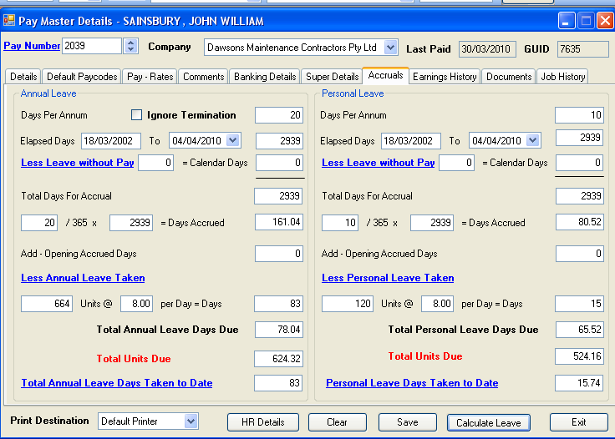

The pay rates screen allowed us to enter the number of days per year the employee will accrue leave. The hyperlinked fields can be clicked to gain more detailed information.

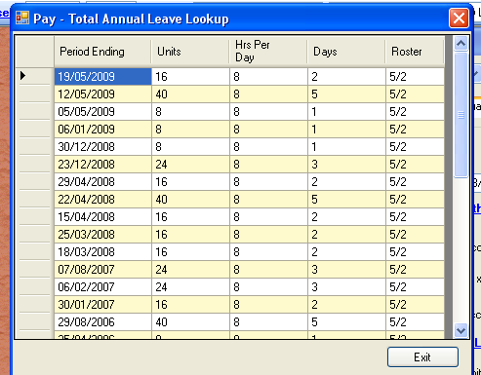
The next tab is the earnings history. Whilst we can view the same information from the query module, it is handy to gain information while performing other tasks. The grids are left blank by default, to save on processing time. Simply enter a date range, or accept the financial year to date. The lower grid (summary transactions) will fill with detailed information based on navigation in the summary details grid.

If you change selected items in the details filter, simply click the “Refresh” button to refresh to summary transactions grid with the currently selected summary details, or click “Refresh Summary” to reapply to all summary details. Clicking the summary / detailed radio buttons below the summary transactions grid will expand to all timesheet entries for details, back to summary per pay code in summary transactions mode.

The next tab is for storage of payroll specific details. This would be employment contracts and possibly medicals for this company. Documents can be any format, however you must consider other users who may have access to this module, and may not have your program installed. It is best practice to store documents as PDF.

The last tab is Job History. This is a quick reference of the jobs for the last twelve months by default. The details view gives more information, and is useful for pay queries, as most non-staff employees are entered daily. This gives an instant picture of what payslip may have been overlooked during payroll processing.

