Job – Journal

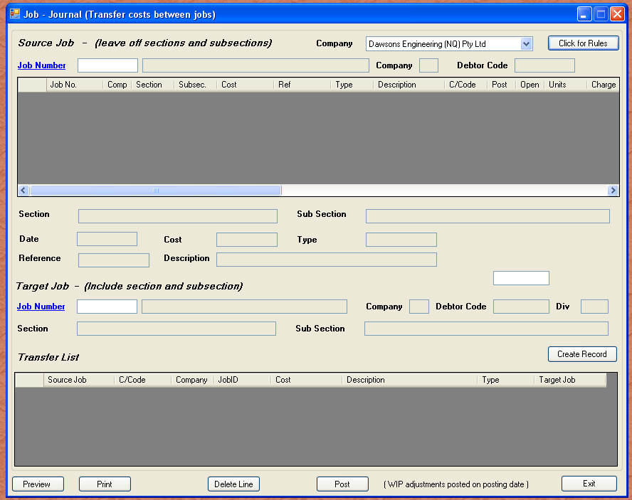
The purpose of a job journal is to correct errors in job cost allocation. Currently we have a very dodgy way of achieving this. That all stops with Tron. You simply enter the job that has the incorrect postings, the select the target job complete with section and subsection, then post. The host job will have a credit transaction created, and the target will have a debit transaction created. Each transaction shows where it came from or went, whichever applies.

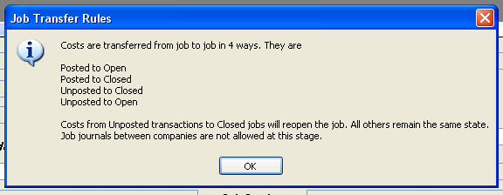

The above explains the rules. Only costs in the same company can be transferred.

