Job – Transaction Query
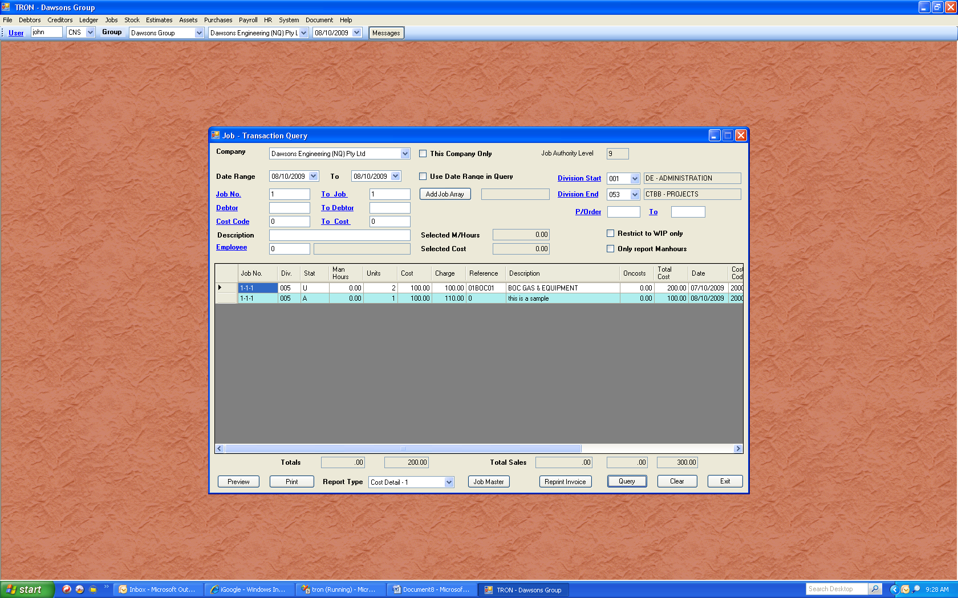
The job transaction query has the ability to filter by a large range of information. You are not restricted to just one job or debtor. There may be a common phrase you know exists in the job description, and you are able to group by this description, along with any other filters you may apply.

Remember, it is wise to start with as little information as required, and then filter from there. You have the ability to jump to the job master from here, or even reprint an invoice, without having to navigate back through the menus.

One important note is the job authority level. Each user is allocated an authority level. The higher the level is set, the higher the authority. For example if I had an authority level of nine, and I created a job, and you had a level six authority, and tried to see my job, then you would be denied for security reasons. However, if you created a job, and your maximum authority level is six, then I will always be able to see the job. As you have probably guessed, I can raise a job lower than level nine so you are able to see the details.

The main purpose for the security is so users do not accidentally or intentionally expose staff salaries and other payments.

