Job – Percent Complete
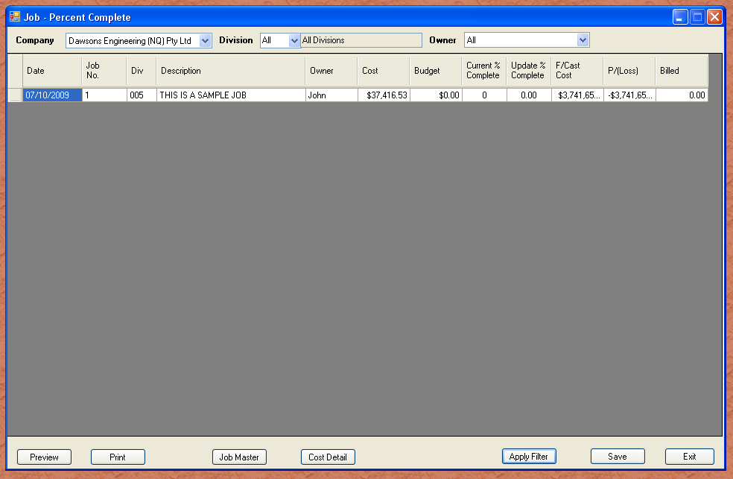
The job Percent Complete is a mass update option. You are able to see all or select jobs open, and update their progress. It would be good practice to review jobs weekly, and invoice or progress the jobs.

When jobs are invoiced, you have the option of closing or progress claiming. If you close the job, all sections and subsections are closed as is the job. Progress claiming leaves the job status as is, and the progress is up to you to determine. The job master will try to predict the job outcome based on your cost to date, and percent complete.

