Job – Master Maintenance
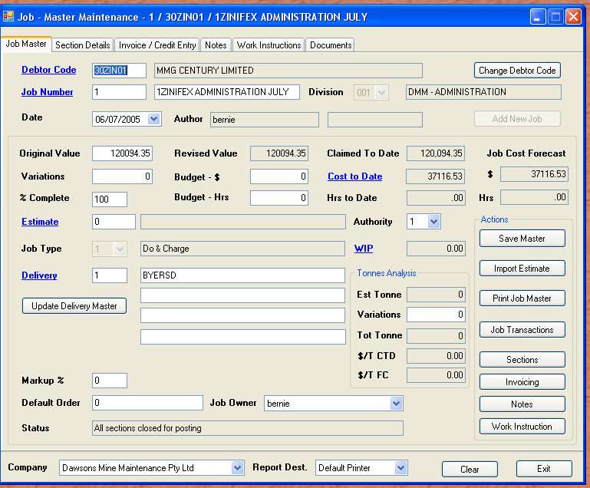

Above is a sample job I prepared earlier. The job title includes all parts i.e. the job number, the debtor and the description. There are a few important steps that must be followed, to ensure the job is created correctly.

To create a new job

Enter the debtor code and click “Add New Job”. The defaults for the debtor will fill the cells. A default section / subsection is created. The most important things to set now are:-

- Enter a job description
- Select the division of the company if not the default
- Allocate an owner to the job
- Add the default purchase order from the client

These are the basics required. You save the job at this stage. Now suppose you have created an estimate and the structure of the estimate is ideal for the structure of the job, you can import the estimate as a structure, along with budget hours and dollars. Simply enter a valid estimate number (or search “Alt + S”) and then click the import estimate. A window is displayed with details of sections/ subsections available to import. You can select only those sections you want.
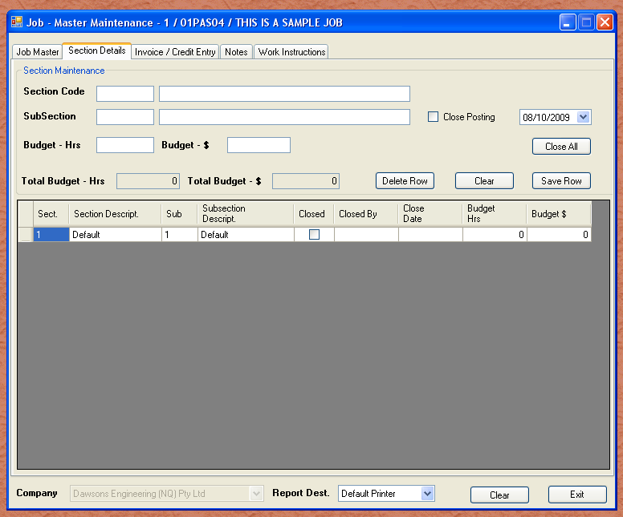
The above tab shows a standard job. Every job has a default section / subsection. If during data entry in any module the job number is entered short eg “12345” for job number “12345”, then the default section and sub section are appended to make it “12345-1-1”. Most jobs are not complex enough to require the multiple sections and subsections, so the default will work fine. An example of a complex structure would be as follows:-

Job “12345” – Construction of ten houses.

Section 1 is house 1, section 2 is house 2 etc. Sub section 1 would be clearing and grubbing, subsection 2 would be foundations, subsection 3 would be walls etc. Therefore the costs allocated to the walls of house 3 under job 12345 would be shown as: - “12345-3-3”.

As you can imagine, each house could be slightly different, so each structure can change. When we have definitely finished a section of the work, we have the ability to close that section, so no more costs go to it. (It would be silly to be booking foundation costs to a house while the roof is going on etc.)

The next tab is the “Invoice / Credit Entry”. We enter a line by line invoice, and select to invoice. If we have to raise a credit note, we simply create a line with a negative value. The job holds all invoices and credits, and reports the total net effect. If you click on different lines of the grid, the invoicing information will change as required.
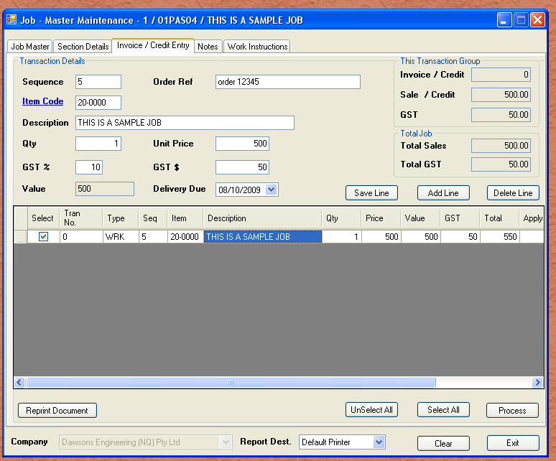
Clicking the “Process” button will select all lines marked as “WRK”(work), and use them to create an invoice. All lines with values will add to the total value of the invoice.
A pop up window asks for invoice date and if this invoice / credit is to close all sections. If not the job is considered to be progress claiming. If the charge line is a negative value, the document is considered to be a credit note, in which case an apply to field will become visible.
In the event the invoice date is back dated, to a period still open, the work inprogress is posted to the periods it relates, and an accrual is created for any cost components in future periods. An eample is a job spans January and February, but you want the invoice dated in January so the customer feels compelled to pay earlier. The dilema is that some of the expense are posted in February. To solve this, all transactions dated after the invoice date are posted to the ledger in the maxium date value of the transactions. The value is created as an accrual in January, and reversed in February. The net effec is that January receives the income, but also an accrual for the costs posted past the invoice date. Similarly, February has the expenses with no income, but has an accrual reversal to offset, so the net is no cost in February. This ensures integrity of costing periods, and the jobs sub ledger.
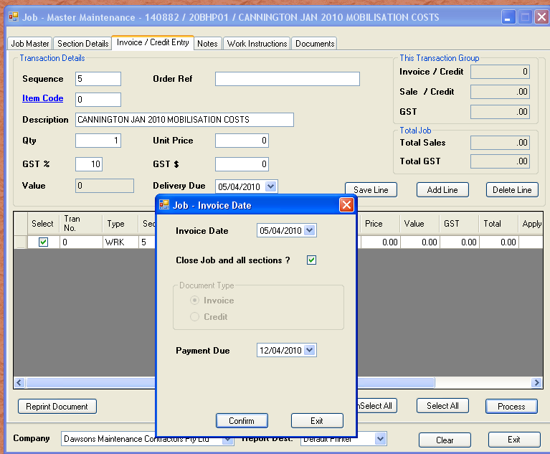

As soon as the invoice has been created, the job master is updated with revised sales information. The invoice lines grid is updated with the invoice number. The main screen for the job indicates the value of invoicing to date, along with percent complete. If a job is closed, the percent complete is 100. WIP will also be set to zero, as all transactions would have been transferred to general ledger.
It is important to note that the invoicing process transfers all costs to date to the general ledger, regardless of the percent complete a project may be. In some cases, it would be advisable to accrue the variance if a job was say advance progress claimed, with no expenses. You would then reverse the accrual as soon as expenses were experienced.
The next tab is the “Notes”. This is useful to enter details about the job, possible local conditions etc, and useful note that you could use if referring to this job at a later date.
The last tab is the “Work Instruction”. This is useful if you have a QA contriolled job, and need to issue specific instructions for this job. You can have unlimited instructions, and each can be printed individually. The idea is to print the work instruction as the job progresses. The instruction can then be used as a QA reference.

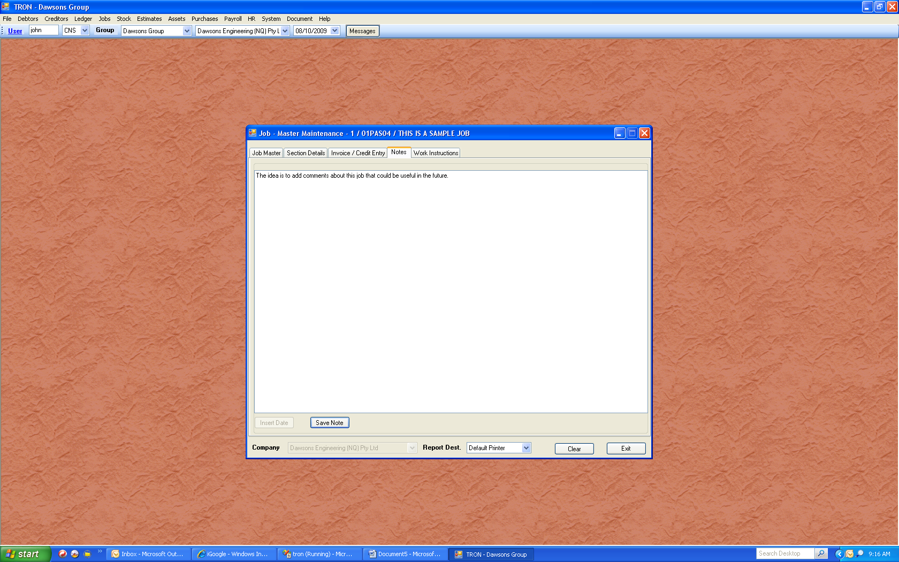
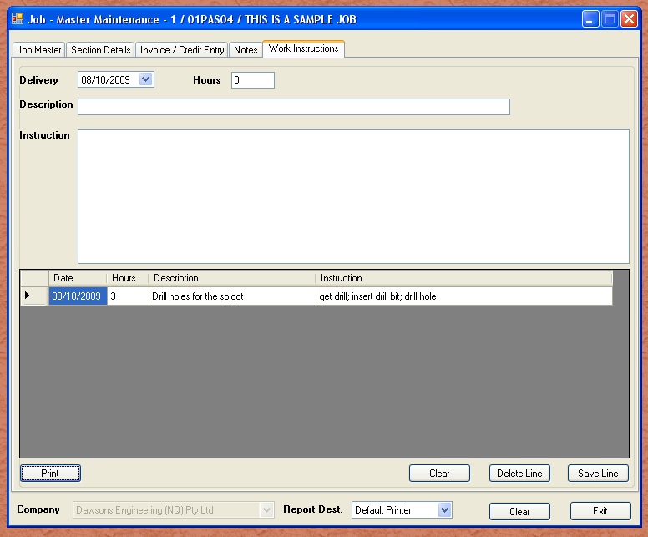
The final tab on the job master is the “Documents”. This tab was added to enable documents to be embedded with the job. As you will see elsewhere, jobs can be found from obscure informaton. Similarly, each job could have unique details that would be handy to store with the job. This could be tender information, drawings, emails etc.
As noted elsewhere, we need to be considerate of what software may be installed on other users machines / devices, so care should be taken to ensure wherever possible, documents are stored as PDF.
Below is a sample document grid, showing how a document has been added. Even though the description may seem vague, this has been embedded by the Accounts Receivable Clerk. The purpose is to show the approval of the cost detail report, so invoicing could proceed.
