Job – Master Report
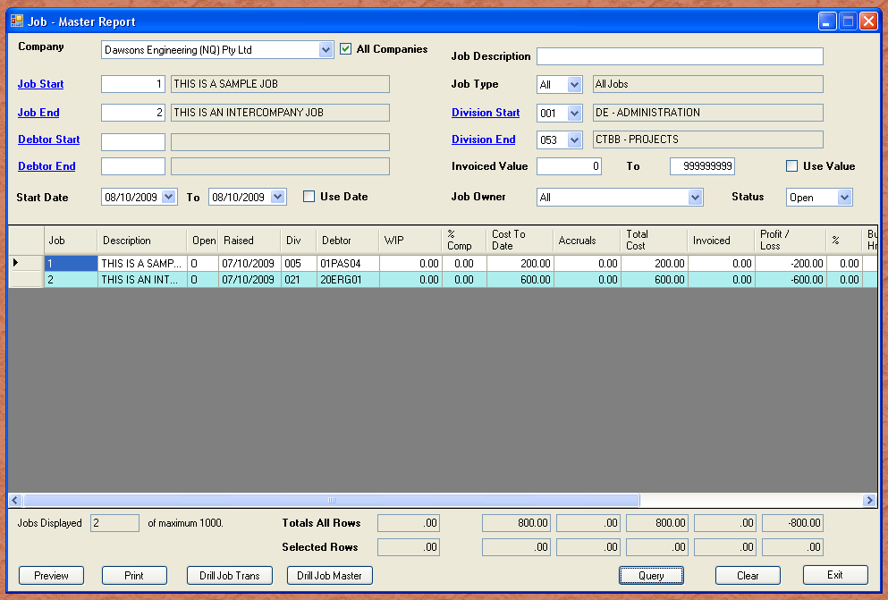
The job master report is for querying the top level job – the master file record. The most common use and default setting is to locate open jobs. You can filter just those jobs under your control, and determine what needs to be invoiced etc.

Jobs record costs in two ways. Actual costs and accrued. The accrued will include purchase orders not fulfilled, as well as timesheets entered, but not posted. This gives real time job costing, as any costs entered in the system in batches, are included as accruals. The general ledger does not take up this as a cost until the batches are posted. It then becomes work in progress.

If you select a complete line, the selected items count will show the values. You may want to add three jobs together. If you select the three jobs (hold down the control key and click the row with the mouse), the values will change as you click each new row.

As with the rest of the system, if the field you are currently in has a blue underlined label (hyperlink) to the left, then you can get a look up by clicking the hyperlink, or pressing ALT + “S”. This is a compatibility issue with Ironbark users.

Notice the aqua coloured alternate grid rows. All modules relating to jobs use this background to distinguish the purpose at a glance.

