General Ledger – Cash Receipt
The general ledger receipt is used for deposits that are not debtor receipts. This could be intercompany transfers for example. By its very name, this receipt option can only affect general ledger and cashbook sub ledger. The example below is a transfer from one company to the other. For one company to require a receipt, the other requires a cheque. This is covered elsewhere.

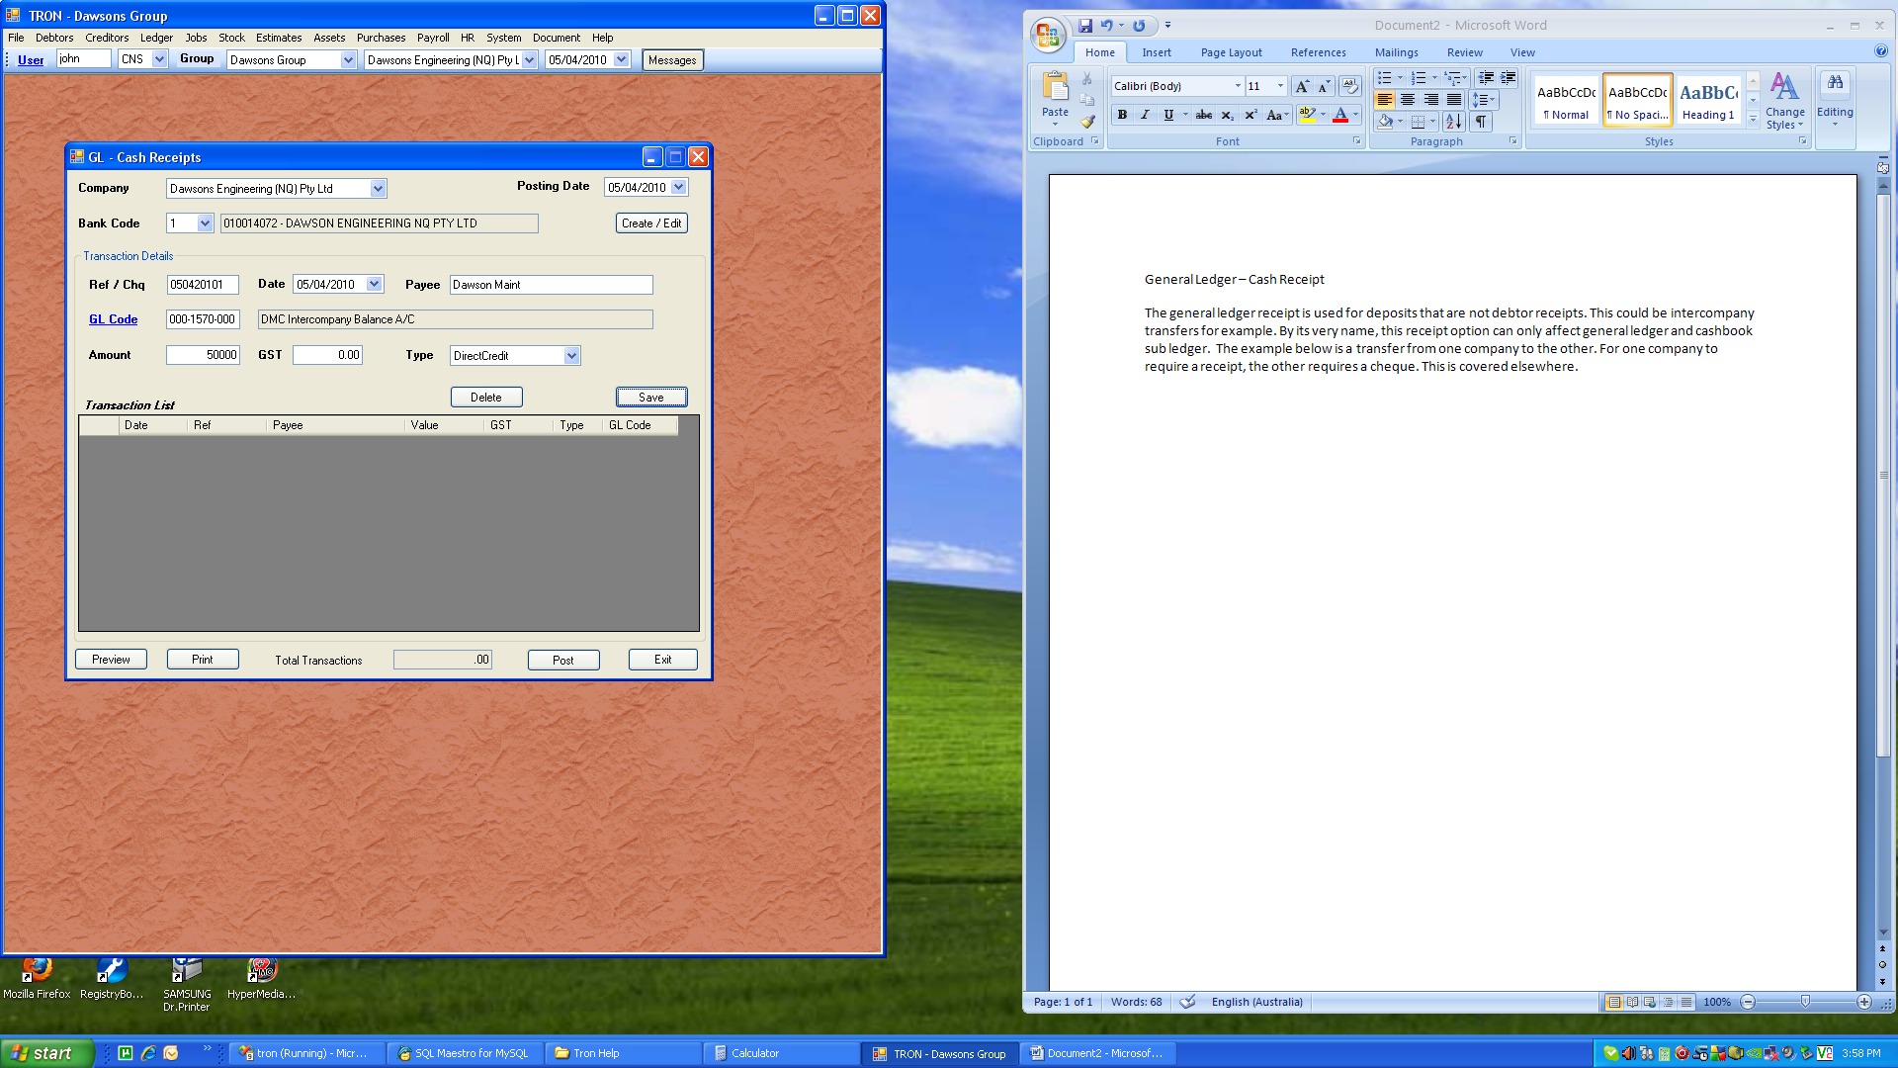

Once the above transaction is saved, it is moved into the transaction list. You can add as many transactions as you like, but be aware the transactions are posted to the general ledger according to the posting date.

The most logical use here is for all transactions that would appear on the current reconciling statement to be grouped. This helps with current reconciling, as well as grouping transaction data in the general ledger.

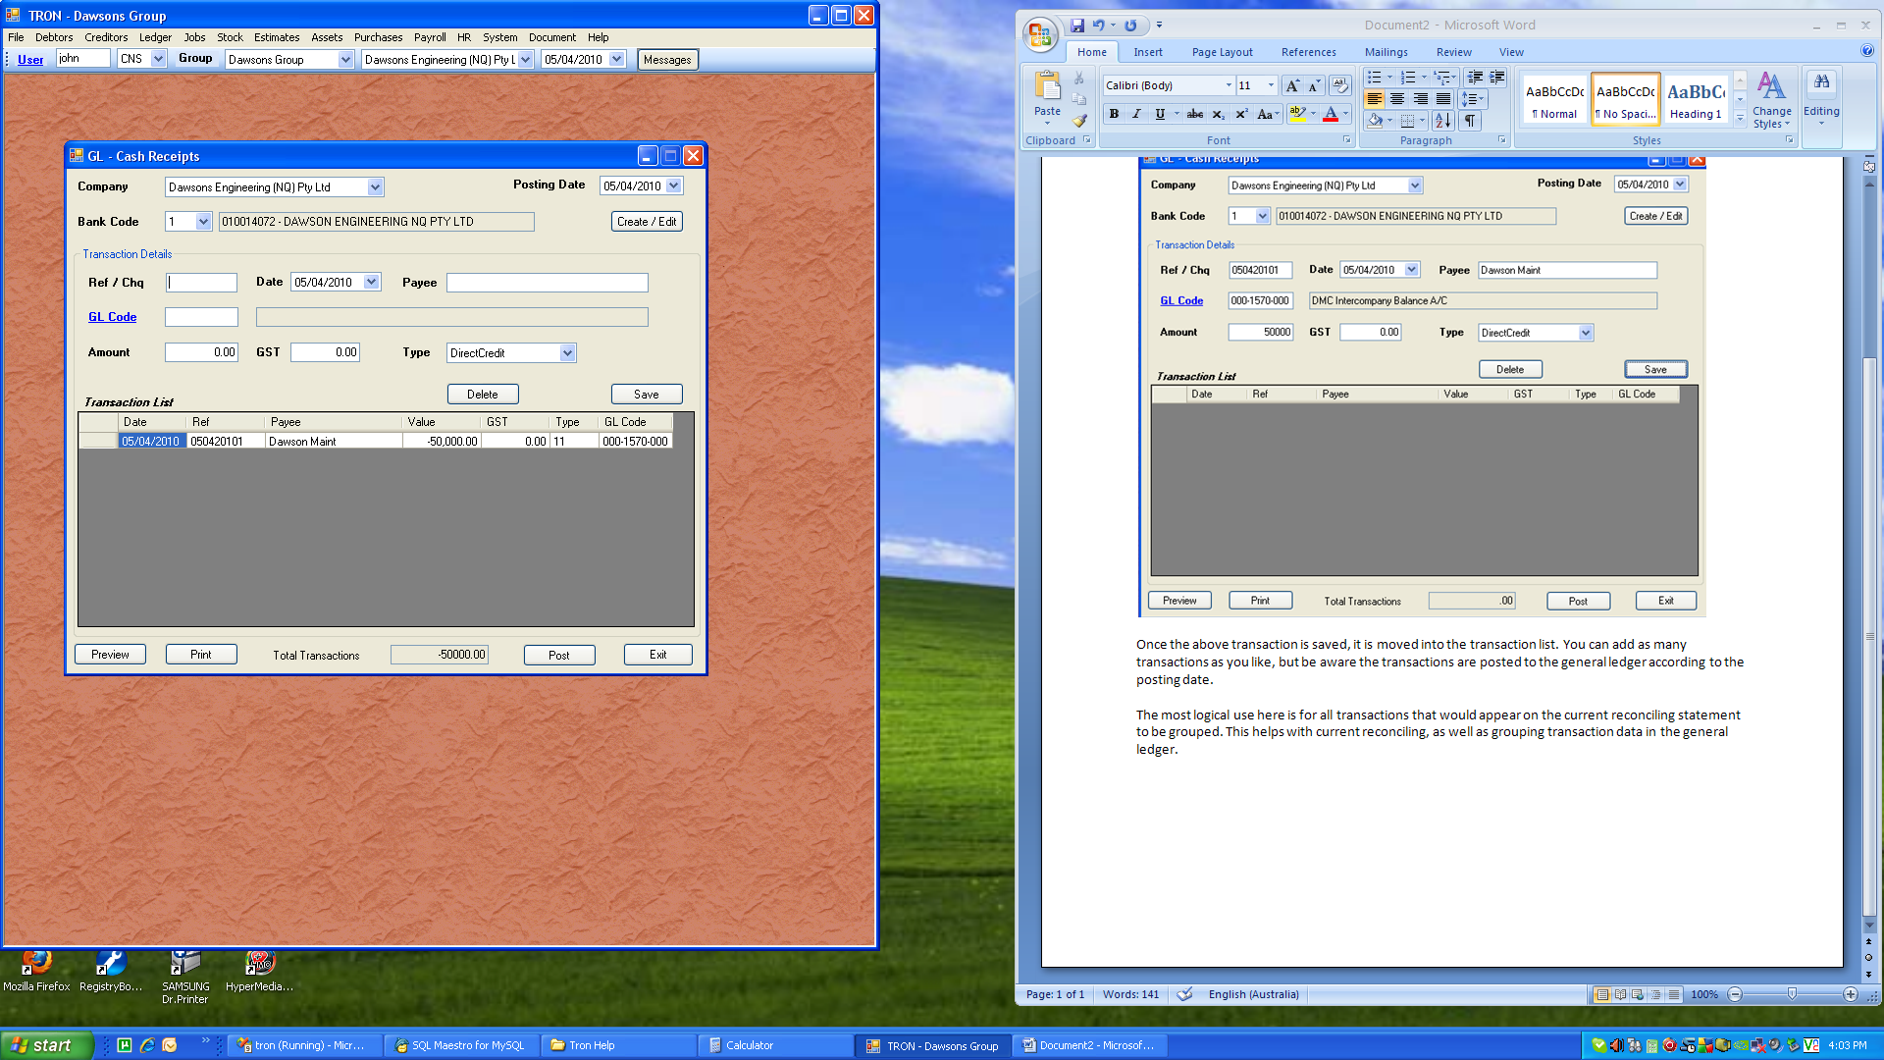

The above shows the previous record is now saved ready to be printed and posted. If the transaction is required to be edited, simply click on the transaction required to be edited, and resave. Similarly, if you want to delete a transaction, simply click that line and click “Delete”. You will not be prompted for confirmation, as this has little impact.

