General Ledger – Cash Payment
This module is used for entry of payments that appear on the bank statement and are not associated with creditors. It is considered better practice to use a cash payment s creditor, so a visible history can be seen. This module is included for those companies who have so few or trivial payments, and are happy to have details kept in general ledger only.

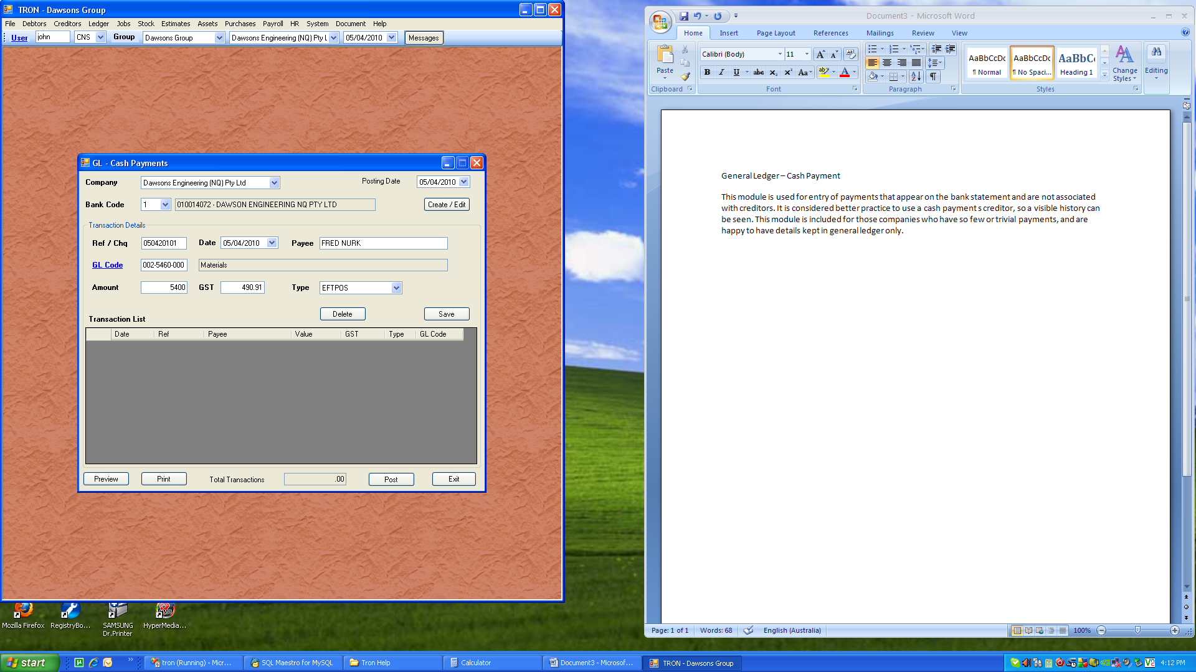

The above entry shows a typical entry. It is assumed the payment had a GST value, however this can be overwritten. Once the payment is saved, it can be printed and posted. To edit the transaction after it has been saved, click the item on the grid. Now that the transaction is the current record, you can edit and save or delete.

You are not prompted on whether to delete or not as this action has little impact. Once the batch is posted, the general ledger control account for cash at bank, and the cashbook sub ledger are updated.

