Accounts Receivable – Receipt Posting
Accounts receivable receipts are matched line by line to a receipt value. The person creating the receipt has the option to receipt all or part of a payment to a debtor master group of invoices and credits. If the total applied does not equal the deposit amount, an unapplied entry is created in the master file. Receipt posting is performed in the “Receipt Posting” module. Below is a sample posting.
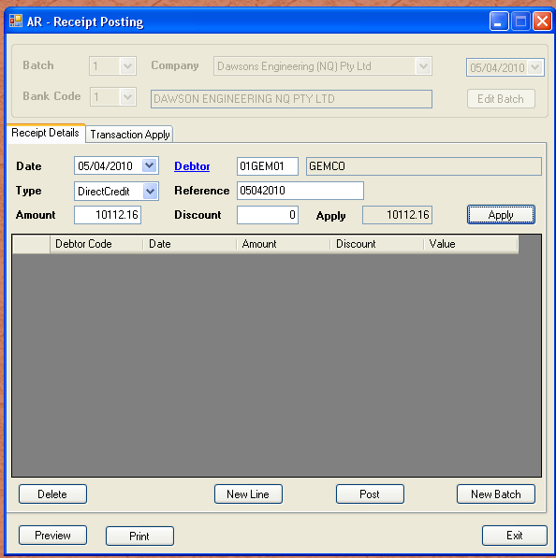
The above shows a receipt with a gross value of $10,112.13. We now attempt to match the invoices outstanding, with the gross value. Usually, we have received a remittance advice from the debtor, and have predetermined the invoices to apply the payment to. Even if we have not received a remittance advice, we use the query module to determine the invoices it should apply against, and if required, we contact the debtor to confirm our selections.
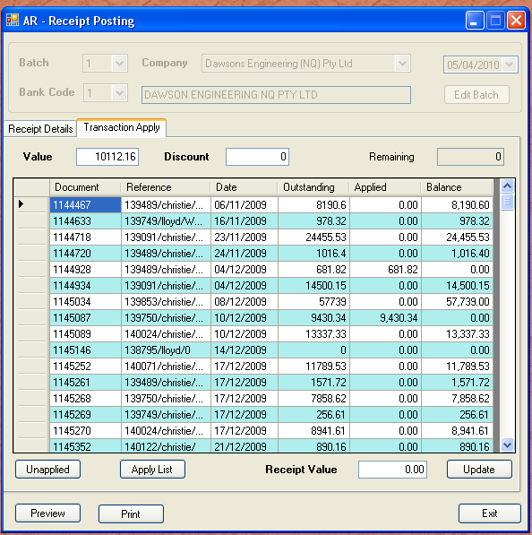

As you can see above, the two invoices applied add to the remittance value, and there is zero remaining to apply. From here we print our selection and post to the general ledger and cashbook sub ledger. The cashbook balance and general ledger cash at bank control account are adjusted with the effecting value.

