Accounts Receivable – AR Query
From the menu select “Debtors”, from the dropdown menu select “Masterfile – Query”

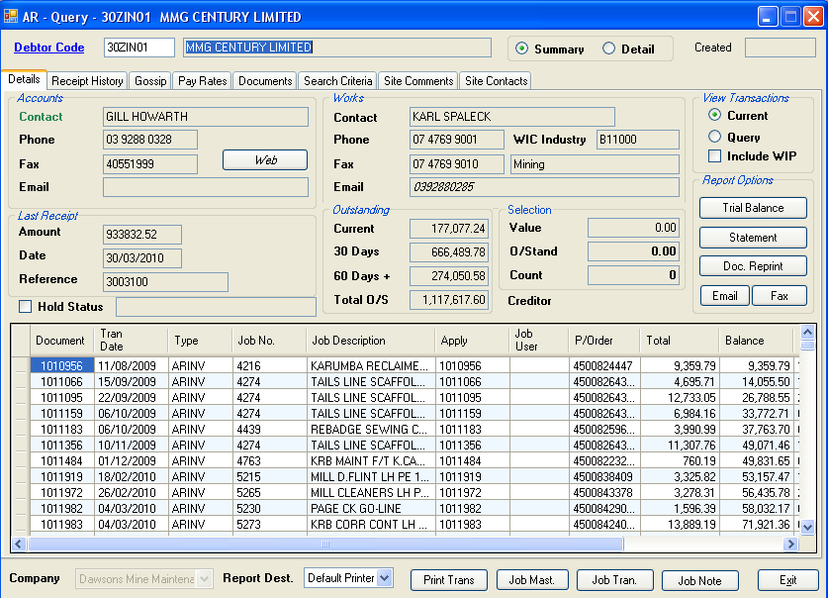
The above is the result of entering “30ZIN01” in the debtor code. This example is from Dawsons Mine Maintenance, as it has historical data we can use. You can show the data in detail or summary view. Like all modules in Tron, if more information is provided, a tabbed window will be used. This example is on the “Details” tab.
From this front screen we can tell the ageing and basic contact details. In the “Accounts” window at the top left the contact label is coloured green. This indicates you can click here for extended information. This will show a pop-up window with mailing address etc.
As with all grids in all modules, the row selector determines the current “record”. In the above case, the current record is document 1010956. If we were to select a document reprint, only this invoice would be printed. If we selected several lines (hold down the control key and click more lines), then they would be included also.
As you can see, you are able to email or fax selected documents (excluding payment references), print a statement or print a trial balance. You can also be redirected to another module based on the current record. For example, if we clicked “Drill Job” we would be redirected to the module “Job -Transaction Query”. Similarly clicking “Job Note” would bring up a pop-up if a note is attached to the job master.
If we click the “Include WIP” check box, the current view is revised to include jobs underway not yet invoiced. If the job percent complete has been updated, this information is carried. The screen shot below shows the current jobs not invoiced appended to the grid. Financial values have not changed, as these are not yet invoices. The document field shows the percent complete, and the type field shows the transaction as being WIP (work in progress). This is extremely useful in deciding credit status for debtors who may be defaulting, as you can determine actual and presumed income.
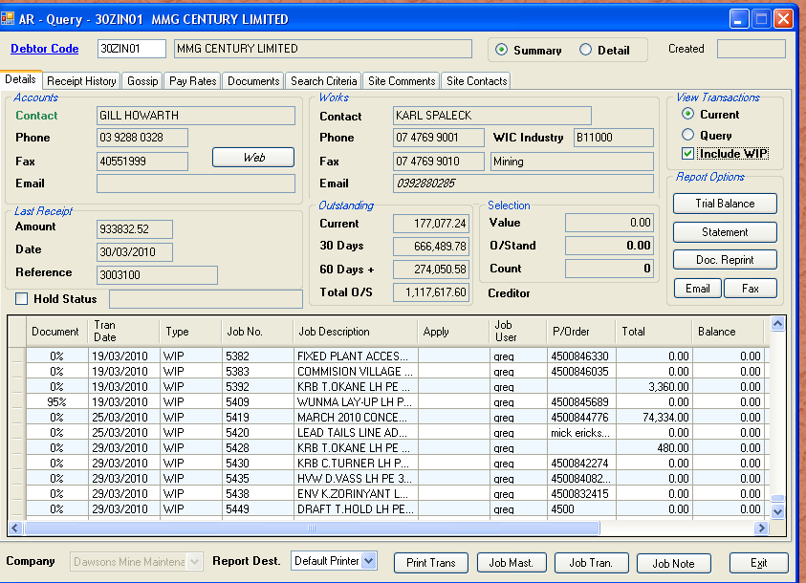

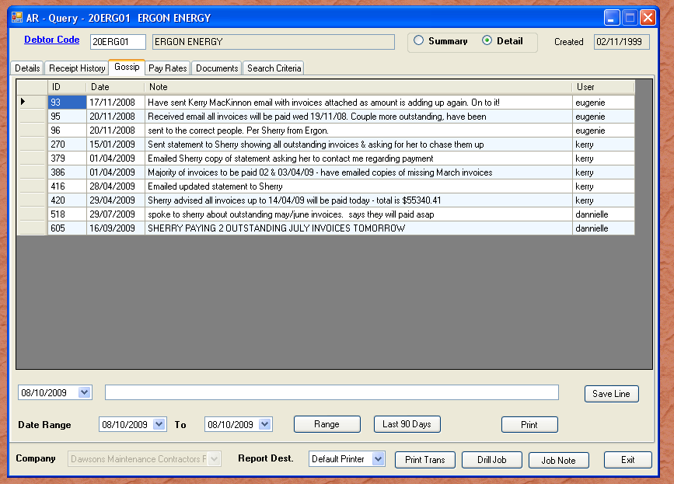
This next tab shows the “Gossip”. This is a running commentary of discussions we have recorded, in attempting to recover outstanding invoices due. If you are creating a job, you should be familiar with the current payment status.
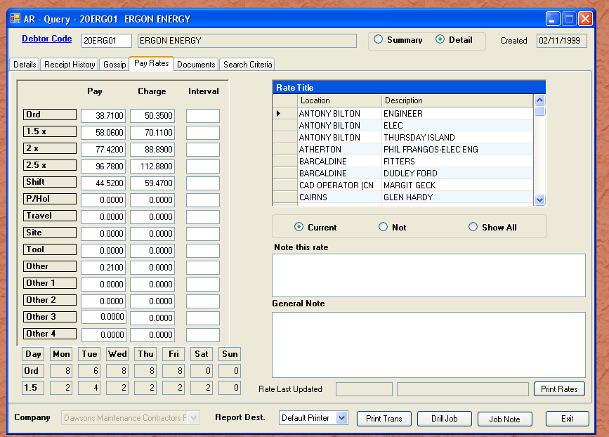
“Pay Rates”
This tab is the current pay and charge rates for labour hire jobs. It can be used to record project specific rates, as these are then available to payroll during time sheet entry. The “Documents” tab has all relevant details such as credit application, rates, insurances and other documents.
“Search Criteria”
This tab lets you “fill in the blanks” to filter the number of records in the grid. By default only outstanding, or records not in history are shown. Simply enter the data required, and click query. You are free to use whatever combination of data to define a query.
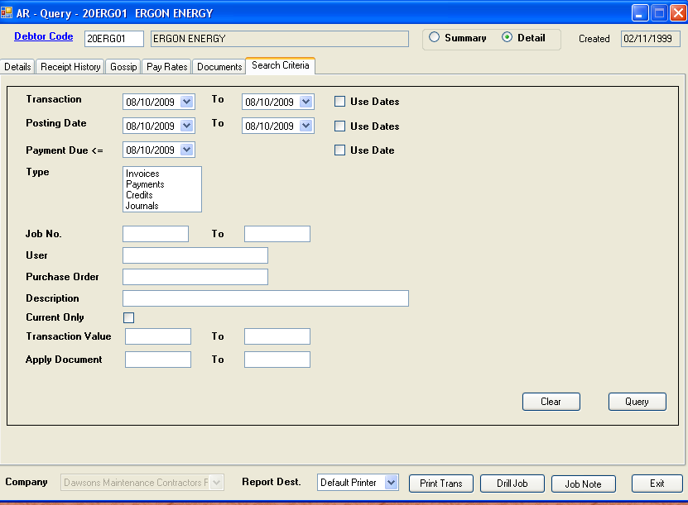
Wherever possible, the grid line colour is a pale blue to signify accounts receivable. The next tab is “Site Comments”. This has been added so marketing personnel and others who visit the sites can add customer spcific details. This could include protocol for safety etc.
The last tab is “Site Contacts”. This was added so again marketing and site visitors can update contact details. This is useful for both ongoing jobs, as well as research for people who may be able to help process outstanding invoices for payment. All employees are encouraged to visit the debtors they have contact with, and update the data.
