Accounts Payable – Invoice / Credit Entry
Invoices / Credits not related to purchase orders are processed via this module. Entries are made in batches, so they can be checked for correctness before posting. Batches can be saved and returned to at any time. A batch number is entered if known, or an unused batch can be used. Clicking the “Batch No.” Hyperlink will display batches and their status.

The posting date is the date at which the transactions enter the general ledger. Unlike real time systems, this module gives you the ability to post in open periods, with much older dated transactions. The benefit is the general ledger correctly displays when the event occurred, and the transaction depicts the ageing of the transaction. An example is where June 30 is the period end, and BAS reports have been generated. The period would be closed. We then find later that invoices arrive for periods dated June and prior. The costs can only be taken up in the current period, but the transactions can have the original date.

With the above scenario, the invoices dated say May, could be posted in July, but will automatically be aged for the payment selections in the Accounts Payable sub ledger. Larger corporations can only operate this way, as regional offices struggle to capture all invoices in all periods. With a real time system, the invoice date has to be altered to comply with processing. Whilst this works, it makes creditor reconciliations difficult.

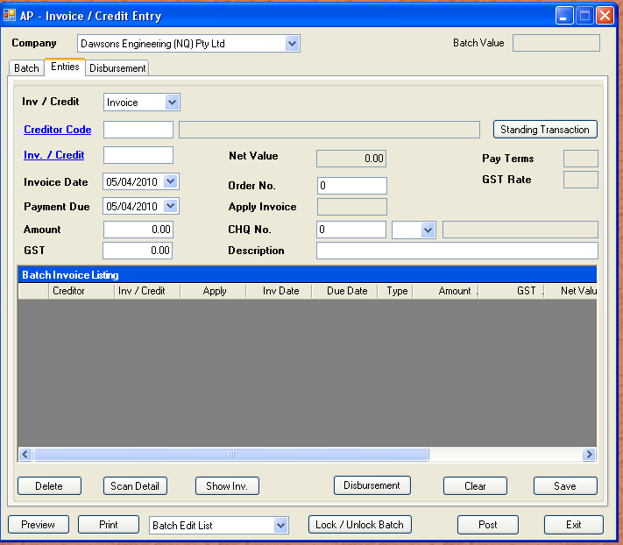

Invoices and credit notes can be entered for any company in the current group (For a discussion on groups, refer to the overview section). Creditor codes must comply with the rules for two digit prefixing, and must already exist in the creditor master file. Standing transactions are those regular recurring events such as rental payments and HP repayments. Whilst rents are generally static, HP repayments have degenerating interest charges as determined in the Asset Master. When a new lease or HP agreement is entered into, interest and principal are amortised monthly. Only leases / HP due in the current month are selectable.

Transactions must first be flagged as invoice or credit. If the transaction is a credit note, then “Apply Invoice” field will be enabled when the selection is made.

Once a creditor has been selected, this will determine if scanned invoices are required. An invoice may not be entered against this creditor without a scanned document, if it is flagged in the Accounts Payable Master File. We next enter a valid invoice/ credit number. The invoice date, amount, GST, order number are all prefilled when the invoice is entered, but only if approval complete. If the document has been approved, we can then view the document or the scan details. In the case of cash payments, or bank statement items that are not regular creditors, we generate an invoice number from the serialised date. An example would be “2503101” would be read as “the first generated invoice on the 25th March 2010”.

Entering through the fields, we can opt to pay this invoice directly. This is aimed at one off payments like rental etc above. If a genuine check number is not used, the serial date method is used for tracking. The cheque number left at “0” will not raise a payment.

The description is what will appear in accounts payable query window. The grid below the data input is a batch summary, and is used to store transactions before posting. Each master record will have at least one distribution. To complete an invoice entry, we click the disbursement button. This will tab to the next screen, where we can enter either job or general ledger details. An invoice can be split between direct general ledger posting, and job WIP transactions.

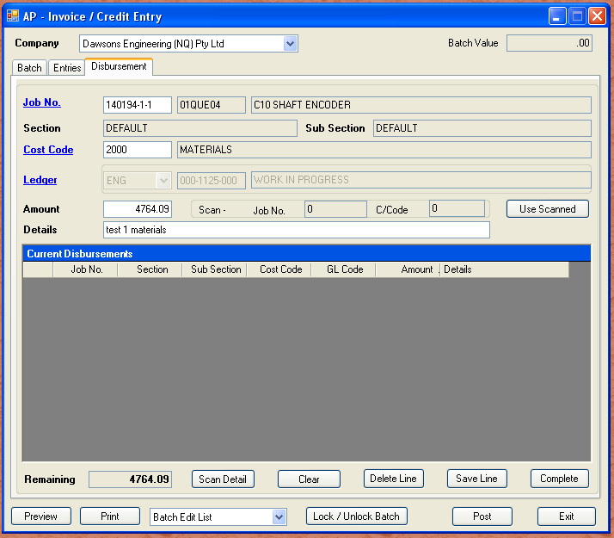

The important details to note in the above sample are that the distribution is the value of the invoice amount less the GST. This is then the gross distribution amount. The “Remaining” counter to the left of the screen depicts how much is remaining to be distributed. The remaining value will not change until the distribution line has been saved.

Once the remaining counter reaches zero, you are able to click “Complete” to finish this transaction. Once all invoices have been entered to the batch, a batch edit list is to be printed and retained. Below is a sample report.

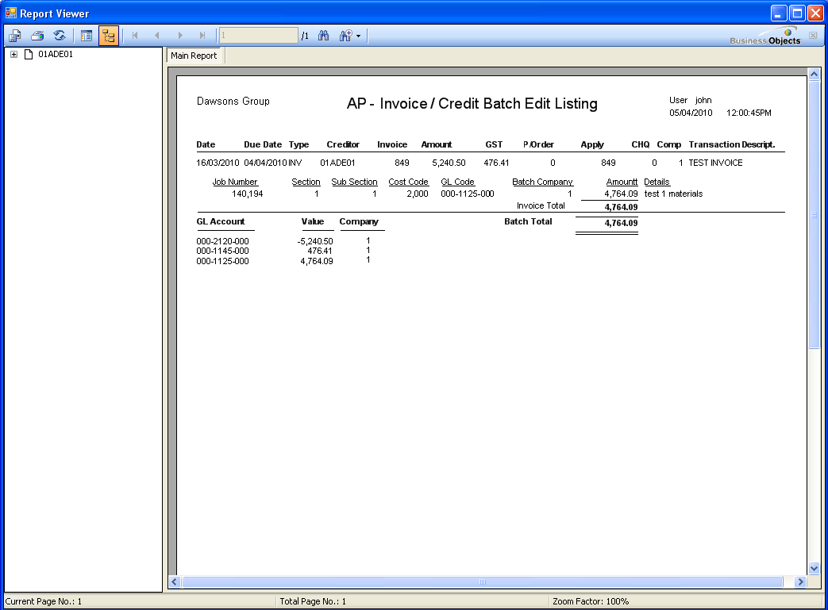

The general ledger listing gives the summary listing of all general ledger accounts to be updated on the date determined by the posting date. Just to recover all ground, the entire batch is posted at one date, not the dates of the individual transactions.

The batch is allocated a unique group number. This means that if we were viewing different potions of the transaction in the general ledger, we could assemble the entire group of transactions based on the group number.

