AP – Transaction Query
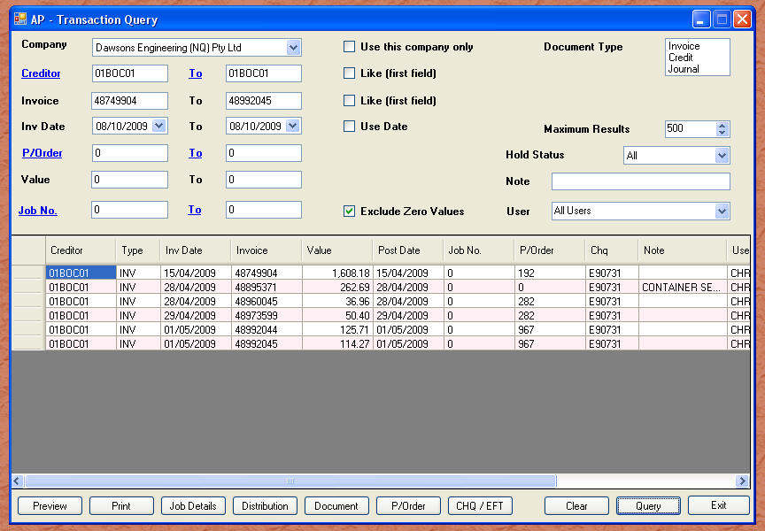

This module allows you to query all transactions of all creditors. The sample above set a range of invoice numbers. Notice the default restricts the result to 500 records. This is simply to stop tens of thousands of records being returned. It is extremely unlikely you would want this many records.

You will notice a number of check boxes that have “Like”. An example of how to use this query would be say “I want all creditors with 01BO” as the creditor. You would tick the check box and enter “01BO” in the first creditor field. Clicking Query would then return the first 500 transactions where the creditor code has “01BO” at the beginning.

Like all grids, you can highlight all rows, or select the ones you want, and press “Control + C” to copy. Open up a spreadsheet and paste the data. To select all rows, simply click the top left square in the row and column region.

Another useful feature is to print all those invoices on hold. Simply select “On hold” from the hold status drop down, and query.

