AP - Query
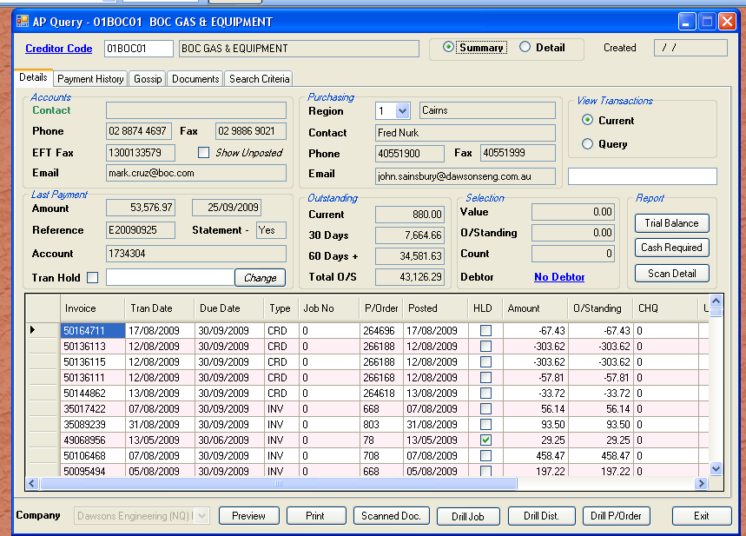

The AP Query module has several tabs. This module is similar to the AR Query, but instead of invoices to clients, we have invoices from suppliers. Payment history is payments made not received etc. The first tab “Details” gives a summary view of transcations by default. If the creditor is setup to have scanned invoices (the majority), then the scanned invoice ID is shown in the grid. If the ID is not zero, then you can view the PDF from here. Similarly, if a job number is not zero, then you can drill to the job.

Purchase orders follow the same schema, but older references may not line up correctly.

The next tab is the “Payment History”. These grids are empty by default, until you click on query. This is to save loading time of the main form. The accounts staff can determine when an invoice was paid, and what other invoices were as well. They can resend the remittance advice by fax / email or printing.

The last module is “Search Criteria”. This is a “fill in the blanks” query. You can search all transactions from history and current. Remember to be vague at first, then refine the query.
