Accounts Payable – Bulk Invoice Loading

This module is used for uploading scanned accounts payable invoices. The invoices must be PDF format. The concept is we arrange our invoices in logical sequence, and scan them in that order. Some invoices may be multiple pages. We create a template to house a table of contents of the bulk scan.

Typically we would scan say ten invoices together. This gives us a ten page PDF document. We now need a template to describe how to slice the PDF file into smaller parts, and upload into the system. It is important the order of the documents never changes once scanning has been done.

Below is a blank uploading grid that would need details entered in the fields below to populate the grid. Scans are created per company in each group.

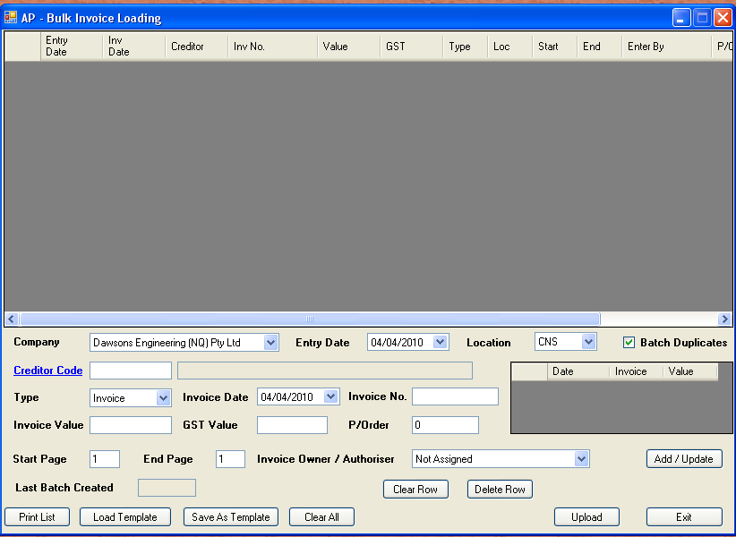

There are only two types of documents. They are invoice or credit. Credit values need to be entered with a negative value. Invoice numbers are checked for duplication during entry. If a purchase order is nominated, the invoice owner is changed to the person responsible for the purchase order.

We assign a start and finish page for each invoice. If the scan is long, it is good practice to save the template. You can then leave this module and continue later. If batch duplicates is checked (by default) invoices are checked to see if they exist in this batch or any other batch.

For self audit purposes, a list of the template can be printed. This is handy for regional offices. If no owner has been assigned to the invoice, the operator is made responsible. This person has the capability to redirect, so it does not get lost to unassigned persons.

Once we completed our template, we click “Upload” to search for the PDF file. The system will check for total page count. If it differs from your count, then it will not be uploaded. If successful, scanned invoices are created and the grid is cleared.

